### Part f - Vertex AI:

### Hyperparameter Tuning

We will use Vertex AI for hyperparameter tuning jobs. The task is image classification on horses and humans dataset from tensorflow

1. Creating a new notebook instance

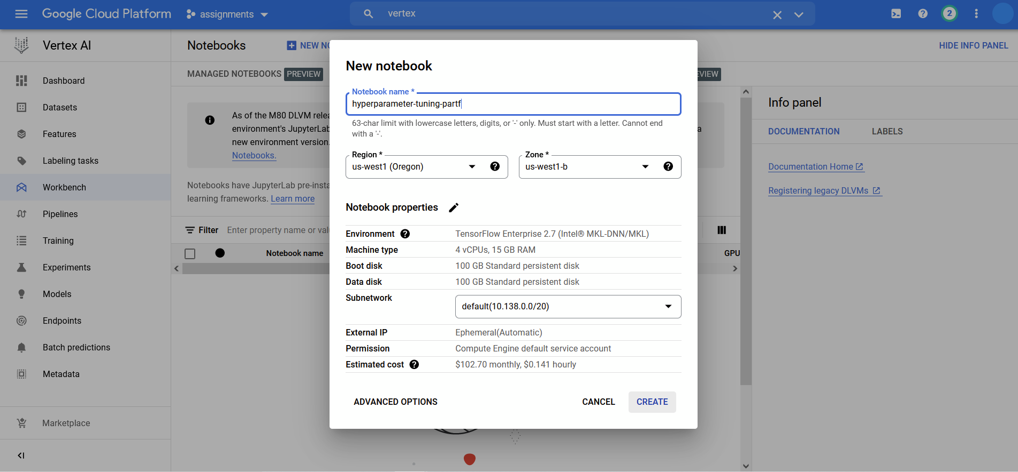

1. Creating a docker file for containerizing the training code

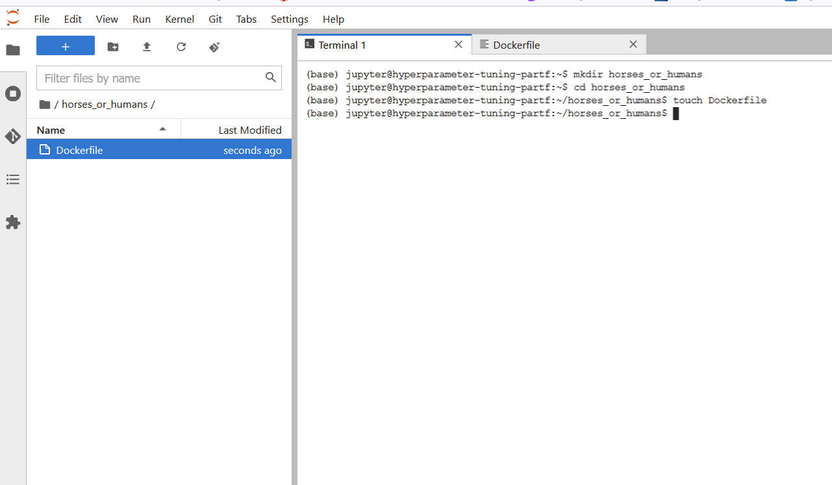

1. Adding the dataset loading, training, hyperparameter tuning code to task.py under trainer

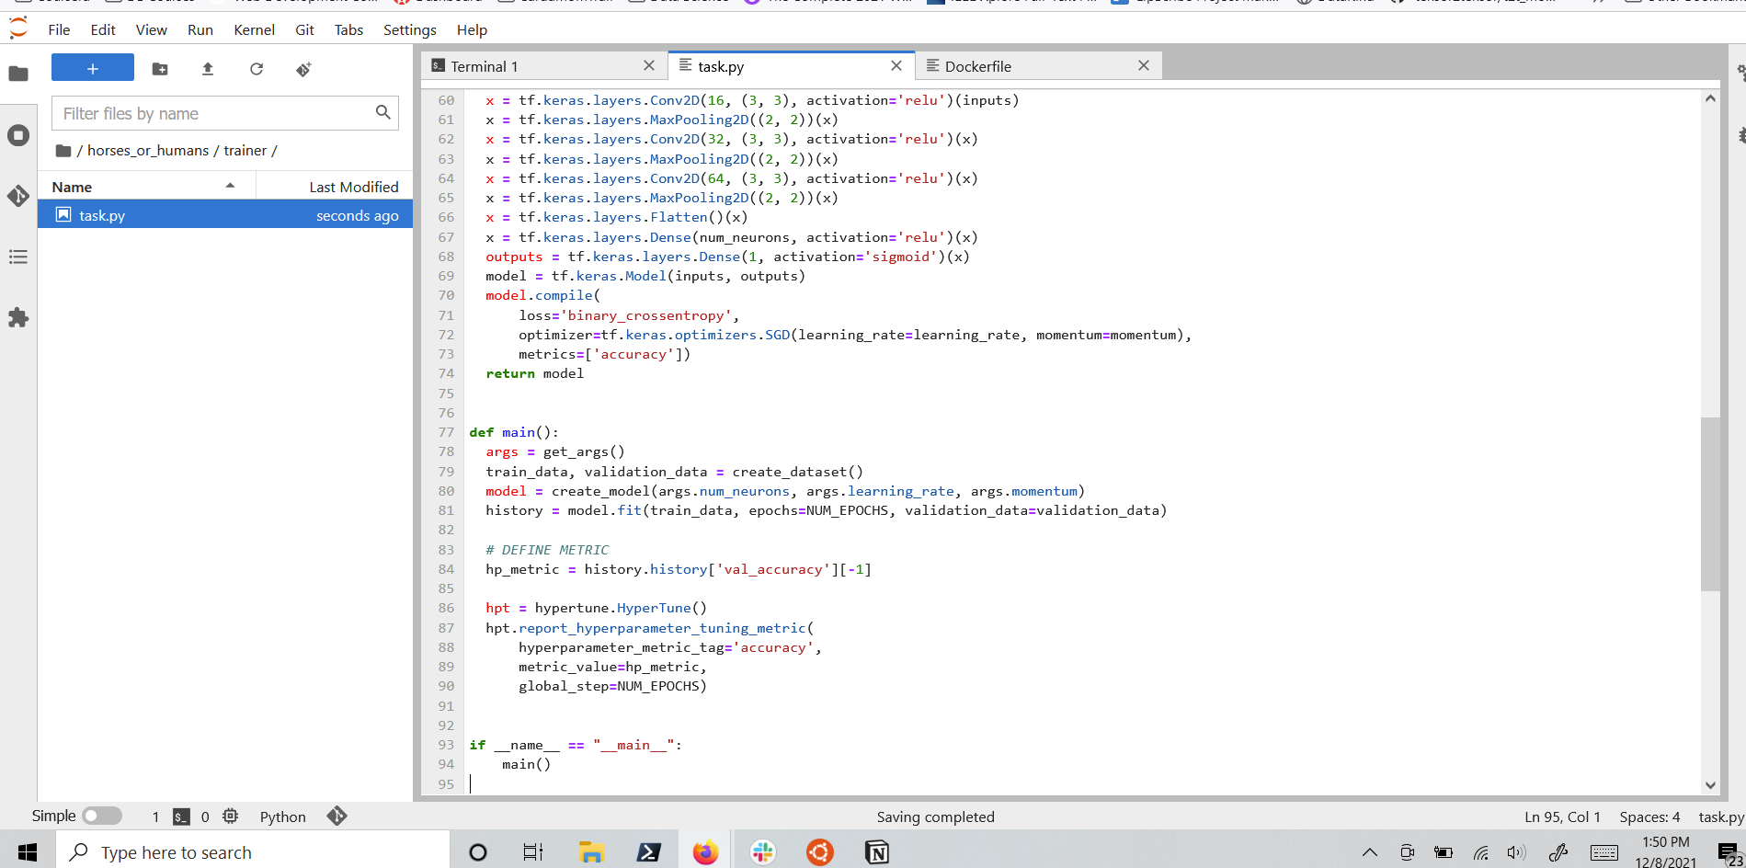

1. Building a container with the hyperparameter code and pushing to google container registry for starting a hyperparameter tuning job

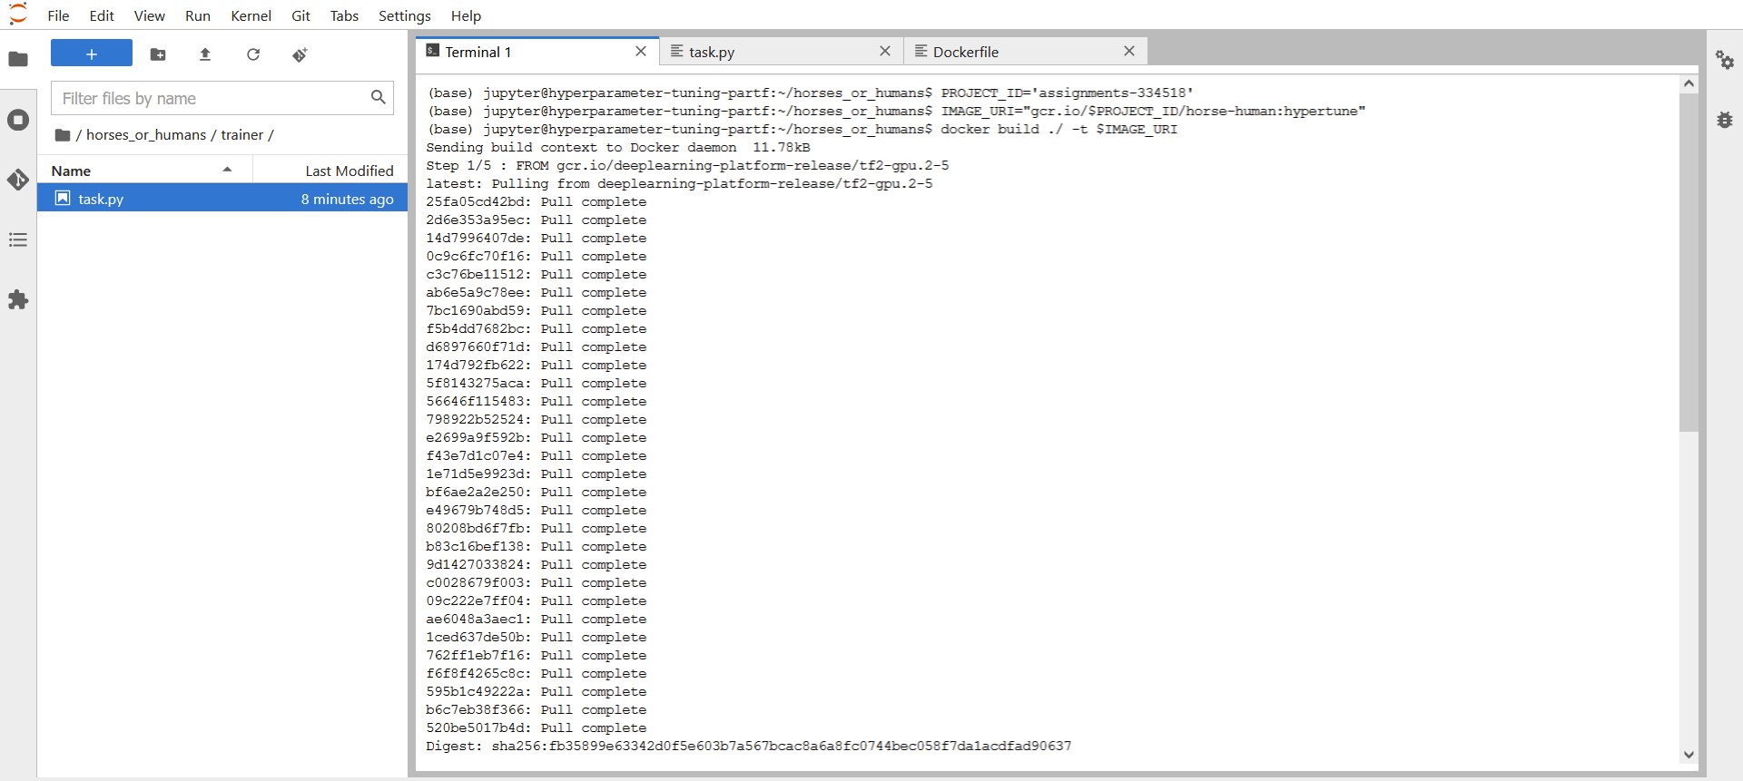

1. Using a custom docker image for the training job

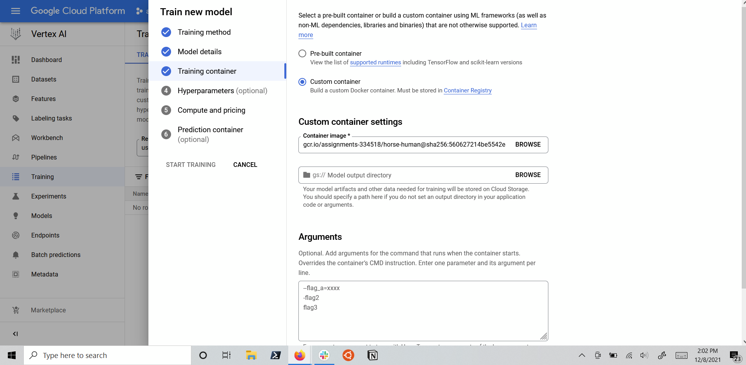

1. Defining which hyperparameters to tune

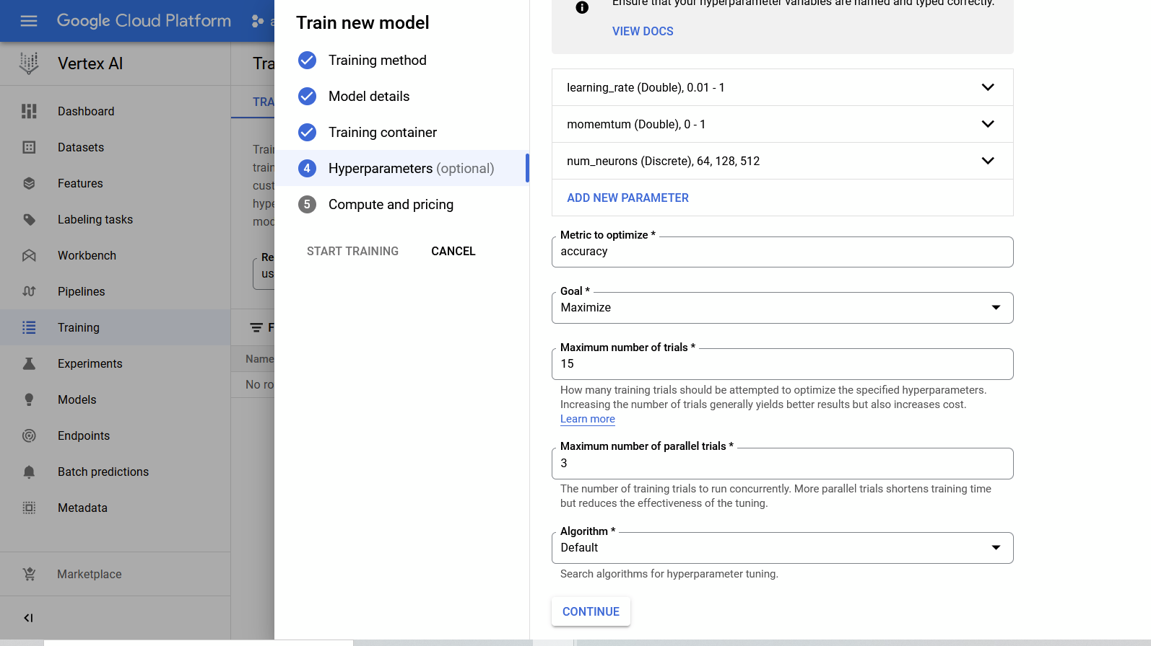

1. Hyperparameter tuning job complete

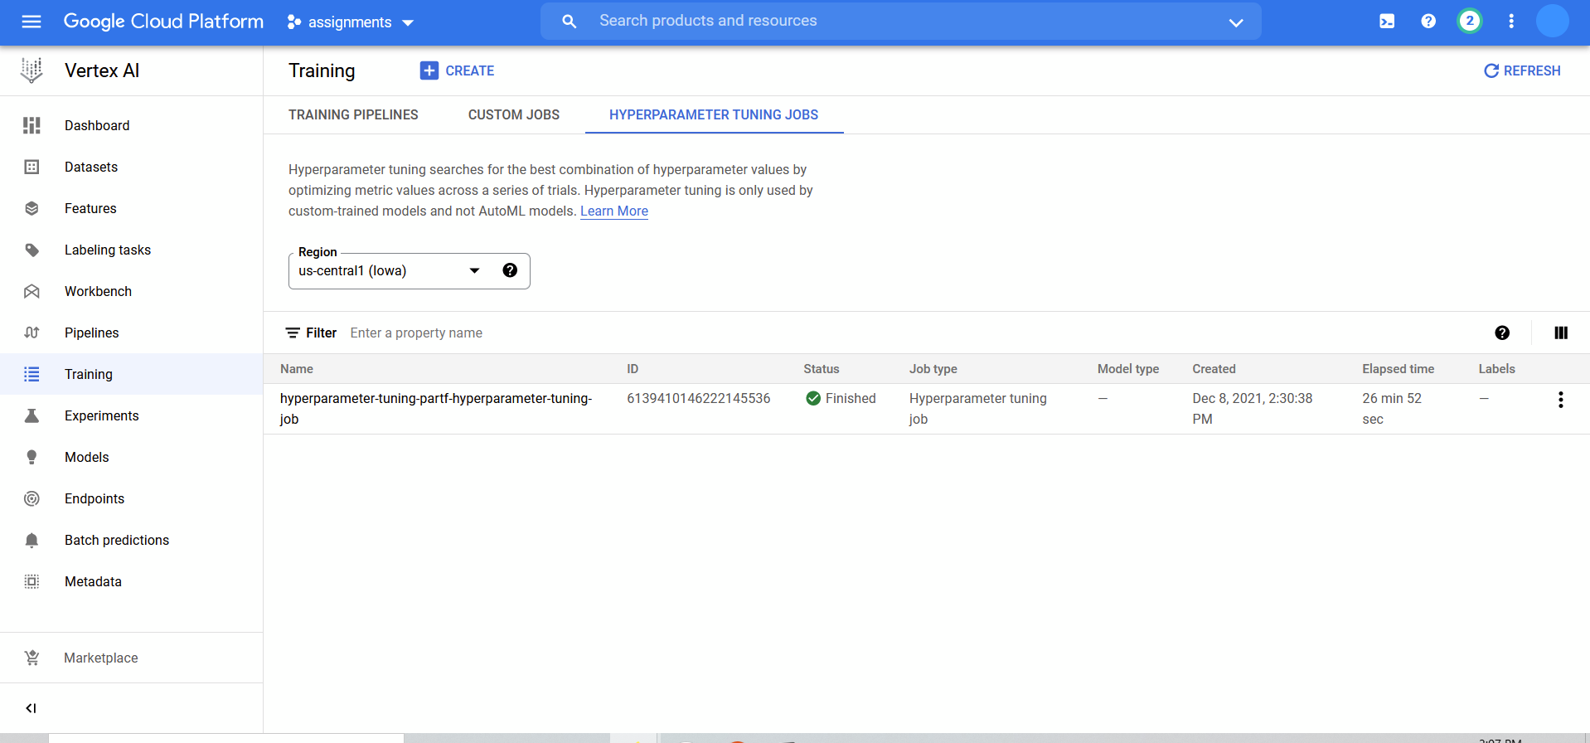

1. Hyperparameter tuning trials

